QUERY
CREATE TABLE bank (
bankname VARCHAR(50),
headoffice VARCHAR(50),
branch VARCHAR(50),
branchcode INT
);
INSERT INTO bank VALUES ('SBI', 'Mumbai', 'Ernakulam', 101);
INSERT INTO bank VALUES ('HDFC', 'Mumbai', 'Kochi', 102);
INSERT INTO bank VALUES ('ICICI', 'Mumbai', 'Kottayam', 103);
INSERT INTO bank VALUES ('PNB', 'New Delhi', 'Kochi', 106);
INSERT INTO bank VALUES ('Union Bank', 'Mumbai', 'Muvattupuzha', 107);
select * from bank;
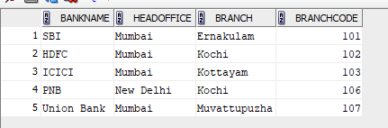
QUERY
commit;
select * from bank;
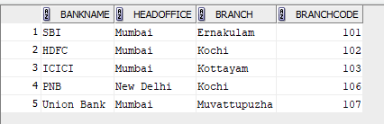
QUERY
INSERT INTO bank VALUES ('UCO Bank', 'Kolkata', 'Thrissur', 116);
SAVEPOINT A;
select * from bank;
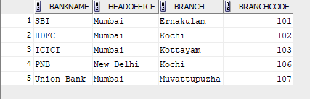
QUERY
ROLLBACK TO A;
select * from bank;
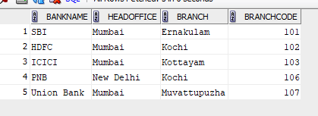
QUERY
grant select on bank to c24csa39;

